Chapter 10, Solution 81.

We need to get the capacitance and inductance corresponding to –j2 Ω and j4 Ω.

The schematic is shown below.
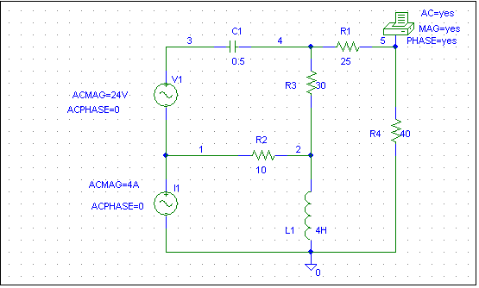

When the circuit is simulated, we obtain the following from the output file.

FREQ VM(5) VP(5)
1.592E-01 1.127E+01 -1.281E+02

From this, we obtain

V_{o} = 11.27∠128.1º V.

